CE206 – Assignment 2

Registration number: 1605177

# Task 1: User requirement review

## Sitemap

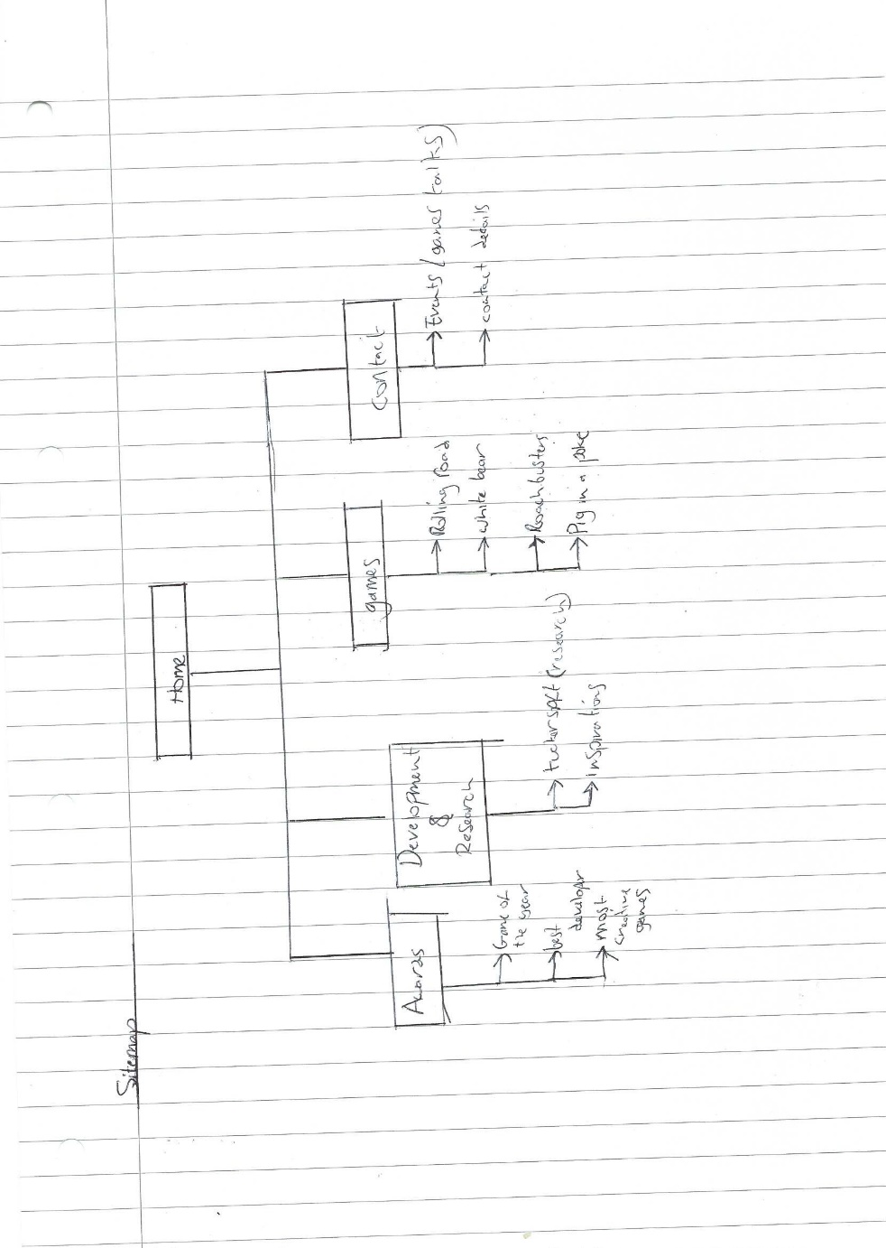

The sitemap above illustrates that the website will have a homepage, awards page, development and research page, games page and a contact page.

## Home Page

This page will be used as the first contact that the potential employer will see as they enter the website. The page will be used to catch the eye of the user to encourage them to look further in to the site. The page will be named “Home” and have a couple of images and a vibrant background along with a small amount of text. Below is the text that will be displayed on the page:

“Welcome! Let me help you make the most of technology.”

The homepage of the site will have the least text and will be more graphically based. The main purpose of the page will be to encourage the user to look deeper into the site.

## Awards

This page will be used as the main page that will help to showcase Collin’s achievements by listing the awards that he has received. The page will use a mixture of text and images to achieve.

Below is the text that will be displayed on the page:

“Game of the year – The game white bear was voted game of the year in 2002 and was described as being “beyond its time”. This is because the game graphic were so realistic and the storyline was intense and addictive.

Innovation award Collin won this award for his game METL HEDD for being able to produce a game based on reality but with a twist of the supernatural.

Best Technology – Collins interest in the field of games development has lead t many breakthroughs in games technology as he pushes the boundaries to make the best games for the best player experience.”

Along with the text above the page will use graphic images of each of the awards to make the page more appealing.

## Development and Research

The Development and research page will be used to show Collins Research in the games industry.

Below is the text that will be on the page:  
“ The future of graphics - From the beginning of computer graphics there has been a great interest in developing methods for producing images that are as real as possible, which is called photorealistic or objective rendering. Over the last few years there has been a great interest in non photorealistic.

Moving the video game industry forward - The CR start-up has developed methods that could help the video game developers and publishers create great products with less risk. There are two main points that the video game industry should utilize in order to achieve maximum success with

The CR start-up method. The first thing is the utilization of the scientific method during the launch and promotion of the game. Using the scientific method will assist the publishers and developers in determining what the consumers are looking for and how to address problems. The second idea is the ability to pivot. Developers should build systems that allow their games and digital products to pivot in many different directions based on consumer response.

How games can improve social interactions- Most young people (at least in countries were social communication technologies are established from a long run) carry mobile devices, surf the Internet and download music. They are always connected and live in a world where the distinction between virtual and real fade.”

The text above will be used along side images and buttons.

## Games

On this page there will be several images and short texts that will show the user information on the most successful games that Collin created.

Below is the text that will be on the page:

“Please feel free to browse through the games for more details just click the game poster.”

## Contact

This page will be used to display a list of events and talks that Collin will be attending such as comic con and ted talks. This is so his fans or future employers know where they can see him and may help get a better understanding of the type of person he is. The page will also contain Collins cotact details such as his email address and number.

Below is the text that will be on the page:

“ See Collin at the following events!

APRIL 2019

London Games Festival

A city-wide celebration of video games, encompassing a myriad of events such as the LGF Hub, Now Play This and Ensemble exhibitions, Games Finance Markets and a games character cosplay parade.

More Than Just A Game V

MTJG V is dedicated to the role that games and interactive entertainment play in society and their profound impact on human interactions and in our democracy. Leading international academics, practitioners, in-house counsel and industry experts will discuss how the rules of the games and the legal structures of the ‘real world’ interact with one another

MAY 2019

Casual Connect Europe

Join us in London on 28 - 30 May 2019 to explore how your creativity and business can merge to create beautiful games. Learn from over 100 leaders in established and emerging markets of the games industry – covering game design, esports, social casino, funding, next-generation technology and best practices.

Or get in contact with me at [colinritman@gmail.com](mailto:colinritman@gmail.com).

## User Experience

### Example 1

#### User Persona

#### User Story

“As a potential employer, I want to see previous projects so I can make an informed decision about whether to contact the potential employee.”

#### User Journey

1. Bridget opens web page

2. Bridget clicks on internal navigation “Games”

3. Page navigates her to “Games” page

4. Bridget finds information

5. Bridget Contacts Collin about employment

### Example 2

#### User Persona

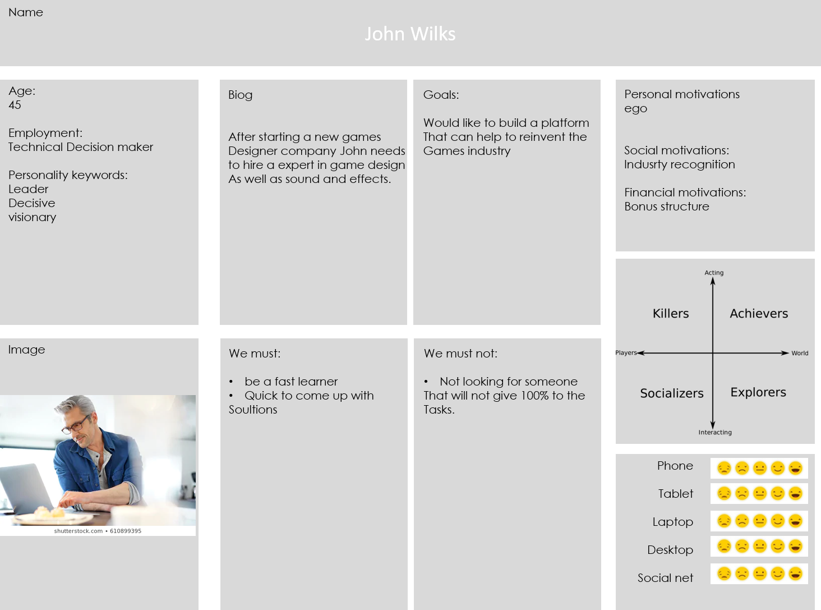

#### User Story

“As a game manufacturer, I want to see awards won so I know that the potential employee is the best fit for the job.”

#### User Journey

1. John opens web page

2. John clicks on internal navigation “Awards”

3. Page navigates her to “Awards” page

4. John finds information

5. John Contacts Collin about employment

### Example 3

#### User Persona

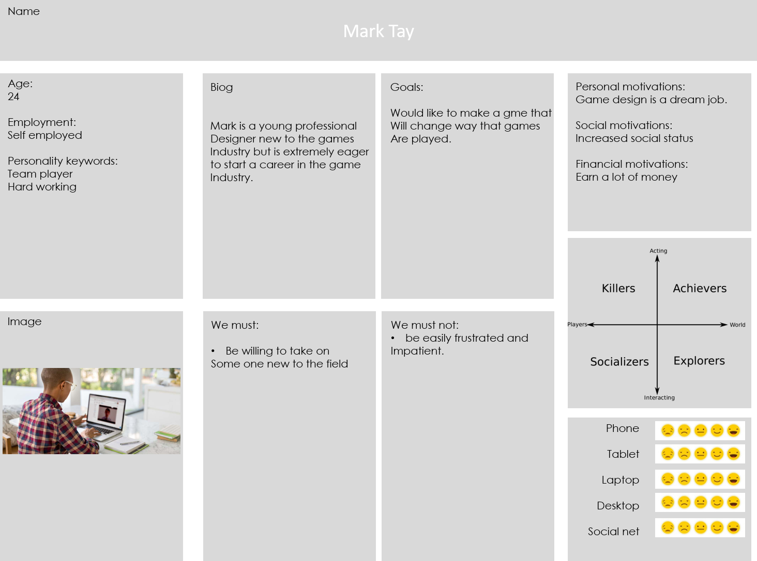

#### User Story

As a newbie in the games industry, I want to know about the person so I know that they will be a good mentor.”

#### User Journey

1. Mark opens web page

2. Mark clicks on internal navigation and looks through whole site

4. Mark reads and gathers information about Colin

5. Mark contacts Colin about helping him as a paid mentor.

## Prototype Website

Below is an image of a prototype webpage which indicates the structure of all the pages. All the pages will have this basic structure as this will make navigation for users easier as they will know how to navigate through each page without having to search each page.

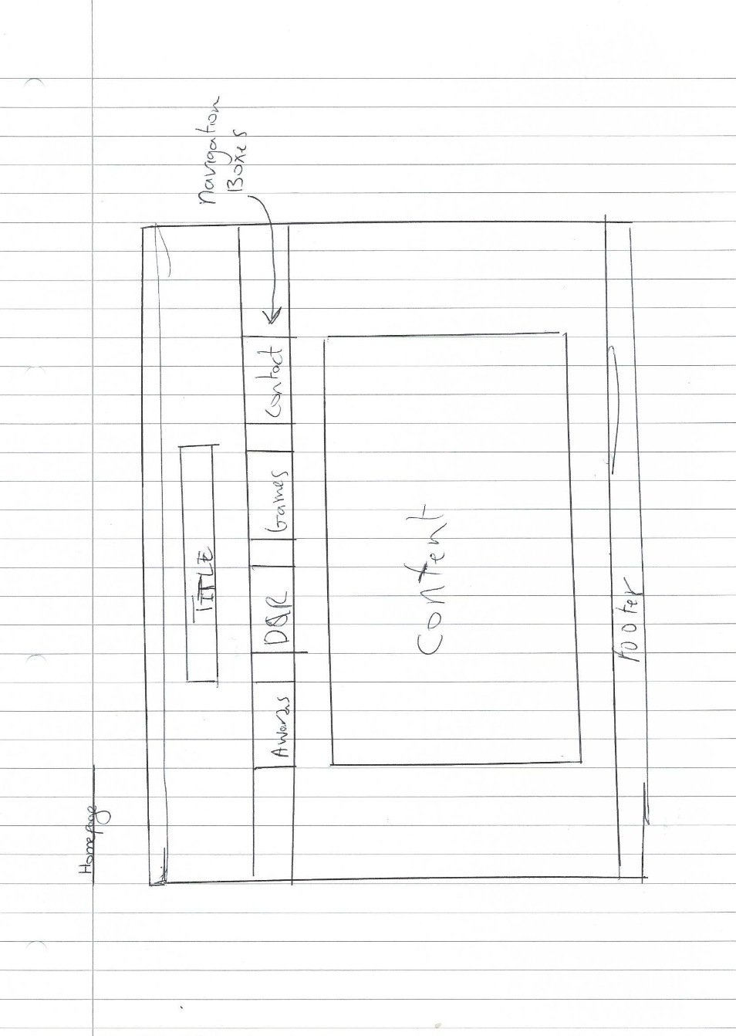

# Task 2: A liquid, adaptive or responsive website design

## Research

* <https://designmodo.com/responsive-design-examples/>

On this site there are many good example of how a responsive site can be used to maximize user experience and ease navigation. The “SparkBox” and “Spidgot design” that were displayed on the site inspired me to change some of the layout from the previous prototype website.

* <https://www.w3schools.com/html/html_responsive.asp>

This site has examples of both liquid and responsive webpages and also can be used as a tool to help create different elements on the page depending on the device that it is being accessed on.

* <https://responsivedesign.is/examples/susan-j-robertson/>

The above site highlights how I can possibly use a CSS grid layout to help organise my site. This will be useful when launching the site as

## Story Board

From the images below of the story board it can be seen what the plans for the site are and how the user would be able to navigate through it using the navigation tab buttons found on each page. In the last image of the storyboard you can also see that designs for the website on a mobile screen. Each of the images details they type of font, colour and idea’s for the backgrounds for each of the individual pages.

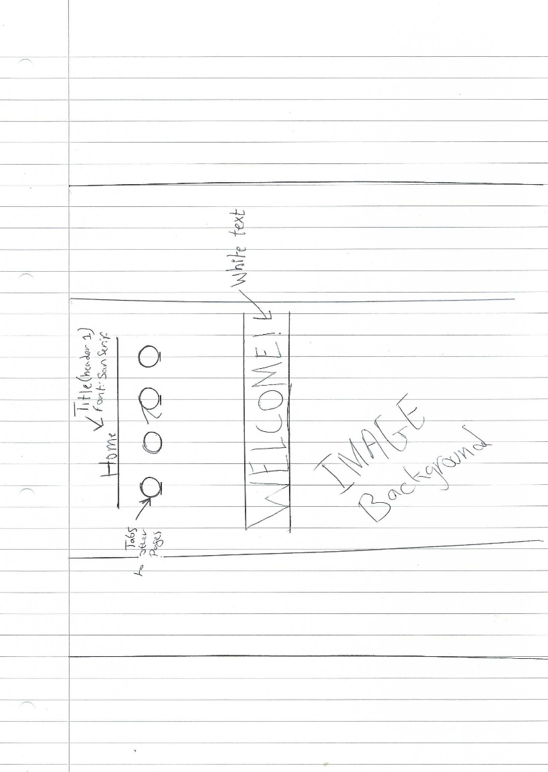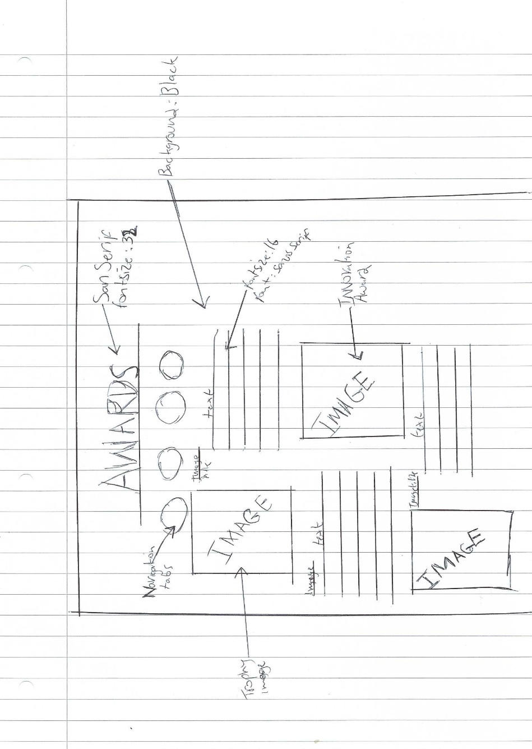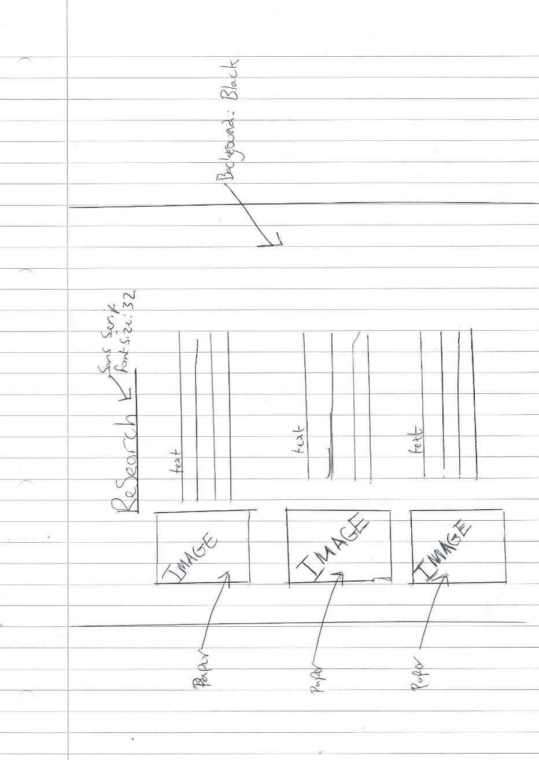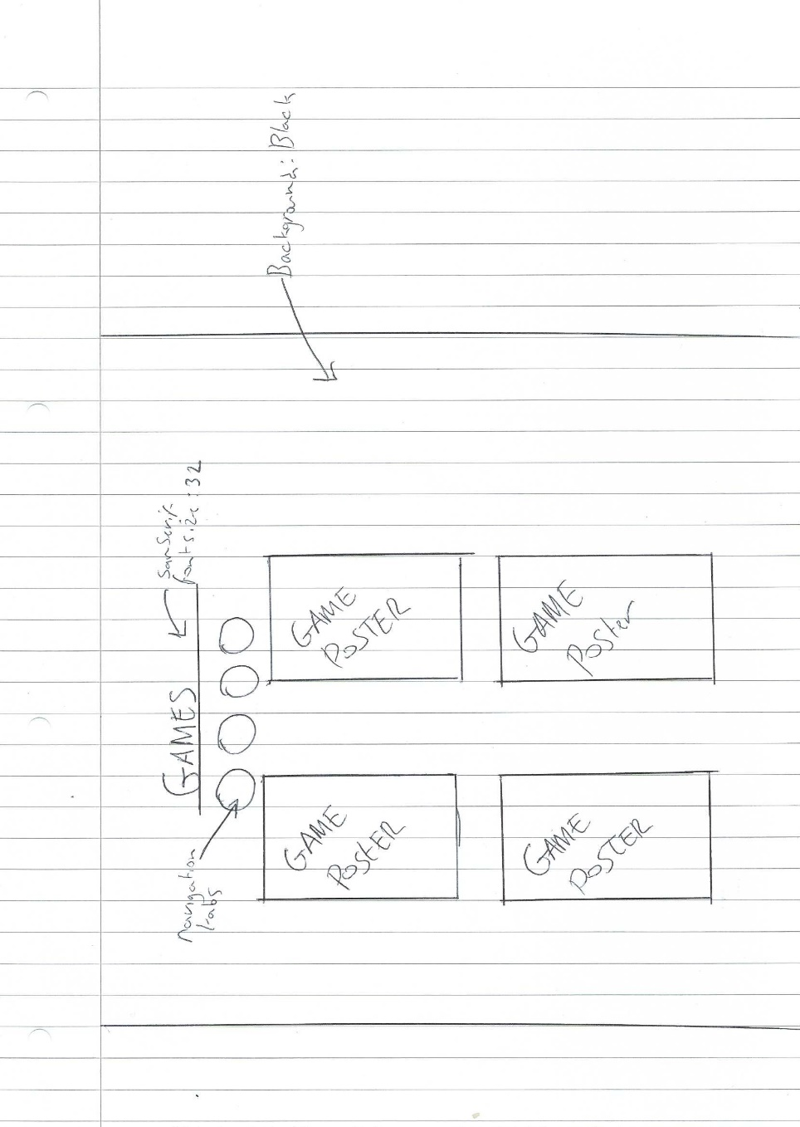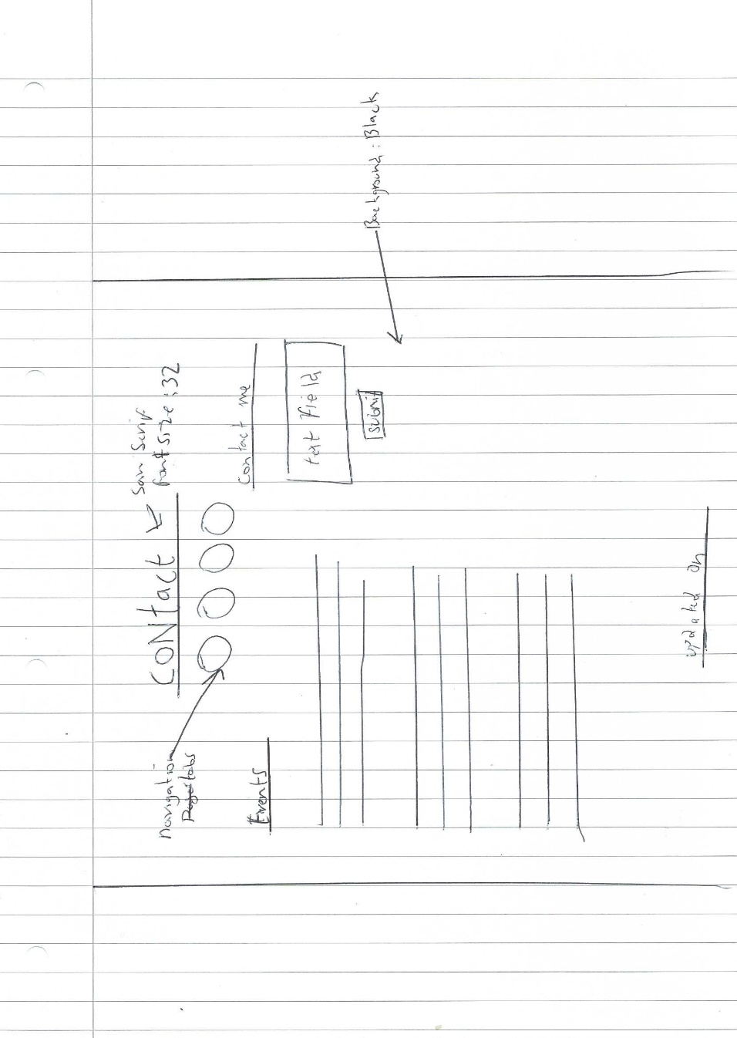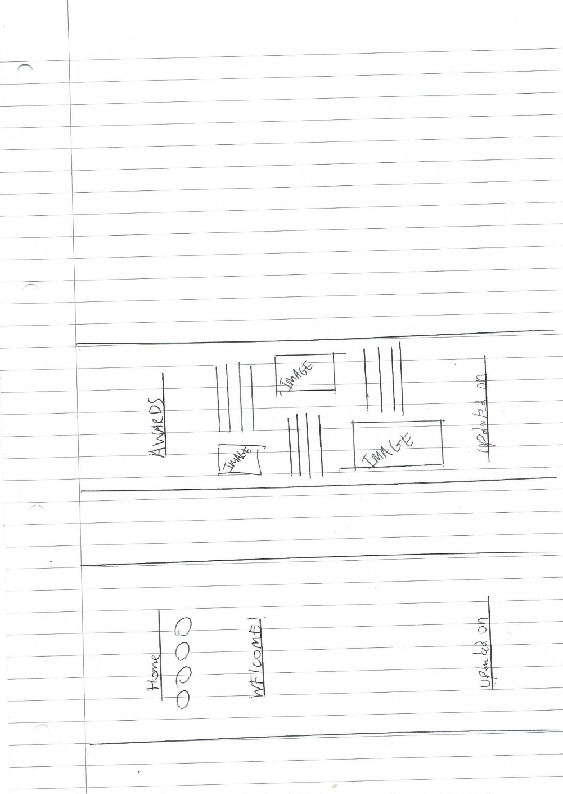

# Task 3: CSS-based website

The evidence of this task can be seen in the html and PHP files.

# TASK 4: Deploy your website to the University server

For this task I deployed the website onto the server and edited the links of each of the pages so that the pages would come from the server. This also allowed for the php code to work allowing an email to be sent to the site admin when a user logs a comment.

# TASK 5: Evaluate your website and propose changes.

## Usability

|  |  |  |
| --- | --- | --- |
| Topic | How it was implemented | What could be improved |
| Learnability | The site uses a basic layout where the navigation bar is at the top of the screen and can be found in the place on every page. I implemented this type of layout as it makes the site very easy to navigate. | In the future of the site when accessing the website from I mobile device I would like to implement that the layout changes.so that it can be more accessible. |
| Colour scheme | The colour scheme that was implemented on the website was black and white. These colours were chosen because black represents power and will. Also it would make a potential employer more serious while browsing the site. | When improving the site in the future I would change the colour scheme to colours that may be easier for someone with a visual impairment to see. |

## Content

|  |  |  |
| --- | --- | --- |
| Topic | How it was implemented | What could be improved |
| Readability | Throughout the website the pages had all the text centred and in blocks, this was so the user would find it easier to read. | Some of the pages have images that do not line up with the text. So as a future improvement I would try to line it all up. |
| Precise information | The website in total had few words but I think was able to show employer’s why they should be hiring colin. | In the future I would expand more on Colin’s background and possibly create a dedicated page for it |

## Talent Tree

### From the start of the course

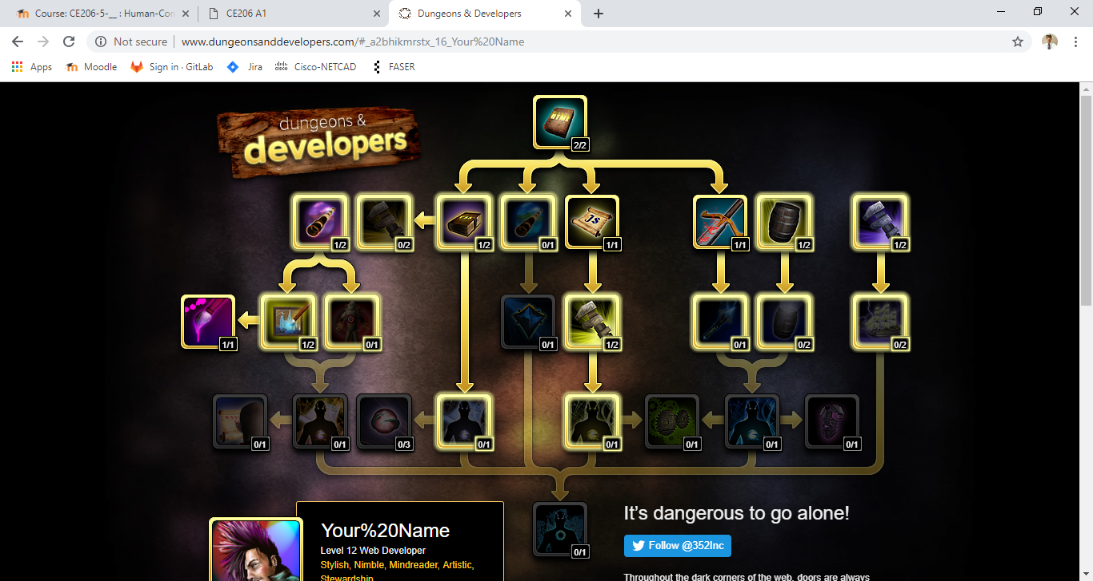

### After the second Assignment

